Vishva patel
Q-1
Gage R&R Study - ANOVA Method

Two-Way ANOVA Table With Interaction
Source | DF | SS | MS | F | P
PARTS | 9 | 52.8265 | 5.86961 | 107.967 | 0.000
OPERATOR | 2 | 1.0455 | 0.52274 | 9.615 | 0.001
PARTS * OPERATOR | 18 | 0.9786 | 0.05436 | 1.551 | 0.140
Repeatability | 30 | 1.0516 | 0.03505
Total | 59 | 55.9022
α to remove interaction term = 0.05
Two-Way ANOVA Table Without Interaction
Source | DF | SS | MS | F | P
PARTS | 9 | 52.8265 | 5.86961 | 138.774 | 0.000
OPERATOR | 2 | 1.0455 | 0.52274 | 12.359 | 0.000
Repeatability | 48 | 2.0302 | 0.04230
Total | 59 | 55.9022
Gage R&R
Variance Components
Source | VarComp | %Contribution  (of VarComp)
Total Gage R&R | 0.06632 | 6.39
Repeatability | 0.04230 | 4.08
Reproducibility | 0.02402 | 2.32
OPERATOR | 0.02402 | 2.32
Part-To-Part | 0.97122 | 93.61
Total Variation | 1.03754 | 100.00
Process tolerance = 8

Gage Evaluation
Source | StdDev (SD) | Study Var  (6 × SD) | %Study Var  (%SV) | %Tolerance  (SV/Toler)
Total Gage R&R | 0.25752 | 1.54514 | 25.28 | 19.31
Repeatability | 0.20566 | 1.23396 | 20.19 | 15.42
Reproducibility | 0.15499 | 0.92994 | 15.22 | 11.62
OPERATOR | 0.15499 | 0.92994 | 15.22 | 11.62
Part-To-Part | 0.98550 | 5.91303 | 96.75 | 73.91
Total Variation | 1.01860 | 6.11157 | 100.00 | 76.39
Number of Distinct Categories = 5

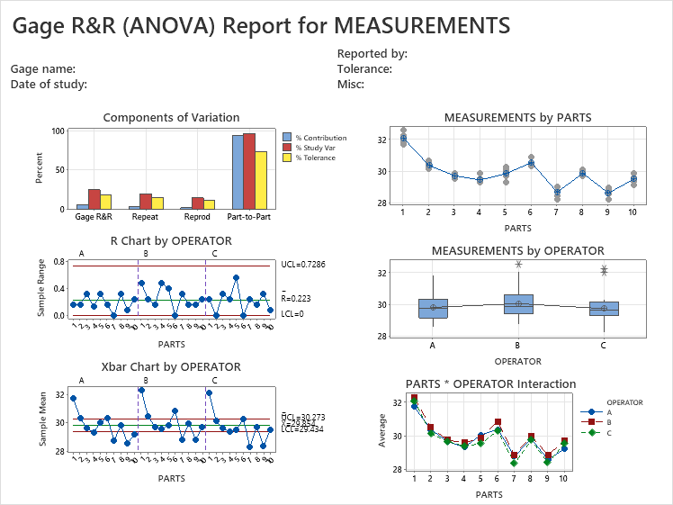

(other part in excel )

Q :2
Analysis of the amniotic fluid from a sample of 15 pregnant women yielded the following measurements on total protein (grams per 100 ml) present 0.69, 1.04, 0.39, 0.37, 0.64, 0.73, 0.69, 1.04, 0.83, 1, 0.19, 0.16, 0.42, 0.20 and 0.79. Suppose population average evidence to indicate that the population variance greater than 0.05?
Minitab Output
X = Measurement of Population
µ is known
n=15
Test and CI for One Variance: Y
Method
σ: standard deviation of Y
The chi-square method is valid only for the normal distribution.

Descriptive Statistics
N | StDev | Variance |  | 95% Lower  Bound for σ  using  Chi-Square
15 | 0.307 | 0.0943 |  | 0.236

Test
Null hypothesis |  | H₀: σ² = 0.05
Alternative hypothesis |  | H₁: σ² > 0.05
Method | Test  Statistic |  | DF | P-Value
Chi-Square | 26.40 |  | 14 | 0.023

Conclusion
- Here, P-value < Alpha (0.05), so we reject H0 at 5% level of significance with Df 14 and we conclude that the data does not provide sufficient evidence to indicate that the population variance greater than 0.05.

Q: 4
The strength of the right and left grips, denoted by X₁ and X₂ respectively, were checked by 12 auto accident victims during routine thereafter exams at a rehab. Center. The observed values of X₁ and X₂ are both coded scores between 0 and 10. Here a low (high) value indicate significant weakness (strength) in the grip. Assume the bivariate normality of X₁, X₂. The data is as follows:
Sr. No. | 1 | 2 | 3 | 4 | 5 | 6 | 7 | 8 | 9 | 10 | 11 | 12
X₁ | 6.2 | 5.3 | 7.1 | 7.8 | 3.7 | 5.4 | 5.0 | 8.2 | 7.7 | 4.9 | 6.5 | 5.2
X₂ | 6.8 | 4.9 | 7.6 | 6.9 | 2.8 | 6.2 | 5.8 | 7.9 | 6.4 | 7.8 | 6.5 | 6.0
- At 1% level test whether mean grip strengths in the two arms are same.
- At 2% test whether the variabilities of the strength in two arms are same.

Minitab Output
- (ii) Variability checking

Test and CI for Two Variances: X1, X2

Method
σ₁: standard deviation of X1
σ₂: standard deviation of X2
Ratio: σ₁/σ₂
F method was used. This method is accurate for normal data only.
Descriptive Statistics
Variable | N | StDev | Variance | 98% CI for σ
X1 | 12 | 1.394 | 1.943 | (0.930, 2.646)
X2 | 12 | 1.405 | 1.975 | (0.937, 2.667)
Ratio of Standard Deviations
Estimated  Ratio | 98% CI for Ratio  using F
0.992065 | (0.470, 2.096)
Test
Null hypothesis |  |  | H₀: σ₁ / σ₂ = 1
Alternative hypothesis |  |  | H₁: σ₁ / σ₂ ≠ 1
Significance level |  |  | α = 0.02
Method | Test  Statistic | DF1 |  | DF2 | P-Value
F | 0.98 | 11 |  | 11 | 0.979

- Here, at 2% level of significance p- value is greater than 0.02 so, do not reject H0 and say that variances are equally for both samples.

- Paired T-Test and CI: X1, X2

Descriptive Statistics
Sample | N | Mean | StDev | SE Mean
X1 | 12 | 6.083 | 1.394 | 0.402
X2 | 12 | 6.300 | 1.405 | 0.406

Estimation for Paired Difference
Mean | StDev | SE Mean | 99% CI for  μ_difference
-0.217 | 1.126 | 0.325 | (-1.226, 0.793)
µ_difference: population mean of (X1 - X2)

Test
Null hypothesis |  |  | H₀: μ_difference = 0
Alternative hypothesis |  |  | H₁: μ_difference ≠ 0
T-Value | P-Value
-0.67 | 0.519

Conclusion
- Here, p-value > 0.01 (alpha), we do not reject null hypothesis and conclude that mean grip strengths in the two arms are same.

Q4 Test and CI for Two Variances: X1, X2

Method
σ₁: standard deviation of X1
σ₂: standard deviation of X2
Ratio: σ₁/σ₂
The Bonett and Levene's methods are valid for any continuous distribution.
Descriptive Statistics
Variable | N | StDev | Variance | 98% CI for σ
X1 | 12 | 1.394 | 1.943 | (0.965, 2.498)
X2 | 12 | 1.405 | 1.975 | (0.622, 3.938)
Ratio of Standard Deviations
Estimated  Ratio | 98% CI for Ratio  using Bonett | 98% CI for Ratio  using Levene
0.992065 | (0.476, 4.291) | (0.532, 5.450)
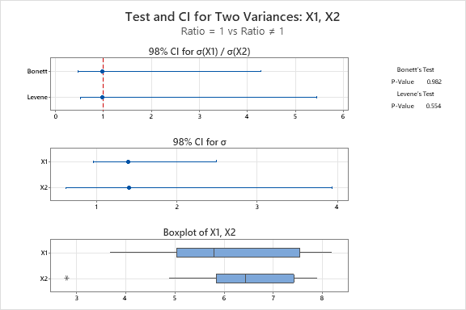
Test
Null hypothesis |  |  | H₀: σ₁ / σ₂ = 1
Alternative hypothesis |  |  | H₁: σ₁ / σ₂ ≠ 1
Significance level |  |  | α = 0.02
Method | Test  Statistic | DF1 |  | DF2 | P-Value
Bonett | 0.00 | 1 |  |  | 0.982
Levene | 0.36 | 1 |  | 22 | 0.554

Q5 Factorial Regression: Yield versus Factor A, Factor B

Coded Coefficients
Term | Effect | Coef | SE Coef | T-Value | P-Value | VIF
Constant |  | 32.083 | 0.816 | 39.29 | 0.000
Factor A | -6.167 | -3.083 | 0.816 | -3.78 | 0.005 | 1.00
Factor B | -3.500 | -1.750 | 0.816 | -2.14 | 0.064 | 1.00
Factor A*Factor B | 2.167 | 1.083 | 0.816 | 1.33 | 0.221 | 1.00
Model Summary
S | R-sq | R-sq(adj) | R-sq(pred)
2.82843 | 72.04% | 61.56% | 37.10%
Analysis of Variance
Source | DF | Adj SS | Adj MS | F-Value | P-Value
Model | 3 | 164.92 | 54.972 | 6.87 | 0.013
Linear | 2 | 150.83 | 75.417 | 9.43 | 0.008
Factor A | 1 | 114.08 | 114.083 | 14.26 | 0.005
Factor B | 1 | 36.75 | 36.750 | 4.59 | 0.064
2-Way Interactions | 1 | 14.08 | 14.083 | 1.76 | 0.221
Factor A*Factor B | 1 | 14.08 | 14.083 | 1.76 | 0.221
Error | 8 | 64.00 | 8.000
Total | 11 | 228.92
Regression Equation in Uncoded Units
Yield | = | 76.2 - 2.97 Factor A - 0.00179 Factor B + 0.000108 Factor A*Factor B
Alias Structure
Factor | Name
A | Factor A
B | Factor B
Aliases
I
A
B
AB
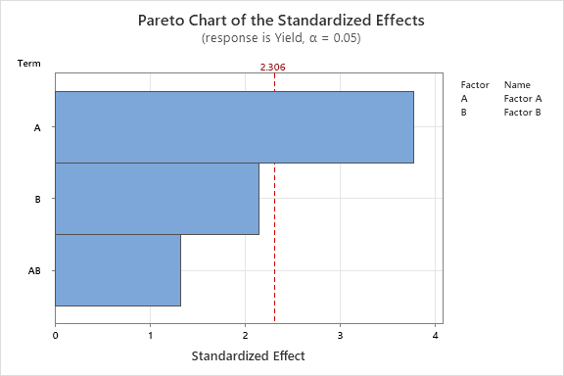
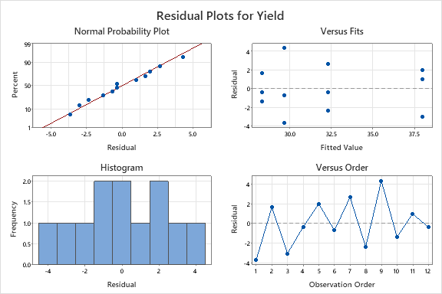

Q5 Full Factorial Design

Design Summary
Factors: | 2 | Base Design: | 2, 4
Runs: | 12 | Replicates: | 3
Blocks: | 1 | Center pts (total): | 0
All terms are free from aliasing.

Conclusion: FOR MAIN EFFECT :
For Factor A has P value is less then 0.05 , we Rej Ho and hence we conclude that Factor A is significant
For Factor B as P value is greater then 0.05 , we don’t Rej Ho and hence we conclude that Factor B is not significant.
FOR INTERACTION EFFECTS:
For FactorA*FactorB as P value is greater then 0.05, we don’t rej Ho and we conclude that it is not significant

